## Install NoiseDiscrimination

Denis Pelli, April 26, 2019

[denis.pelli@nyu.edu](mailto:denis.pelli@nyu.edu?subject=installing%252520CriticalSpacing)

**NoiseDiscrimination.m** is a MATLAB program developed by Denis Pelli at NYU. It measures threshold contrast for identification in static or dynamic noise. Pelli & Farell (1999) explain why it’s useful and interesting to measure thresholds in noise.

Pelli, D. G. & Farell, B. (1999) **Why use noise?***Journal of the Optical Society of America*A, 16, 647-653. <http://psych.nyu.edu/pelli/pubs/pelli1999noise.pdf>

The signal can be known exactly (one of several letters or gratings) or statistical (white noise with one of several known envelopes). To run NoiseDiscrimination on your machine (running MacOS, Windows, or Linux), you need software (MATLAB, Psychtoolbox, and NoiseDiscrimination) and a few tools (a meter stick or measuring tape and a photometer). Please follow the steps below:

### A. Install MATLAB (Already have it? Skip to step 7.)

1. **macOS:** To quickly install MATLAB in one easy step (no matter where you are), copy the following command into the app called Terminal:   
   sudo curl www.cns.nyu.edu/macos/matlab.tgz | tar xz -C /Applications  
   You can run this from anywhere.  This avoids the quarantine-tag obstacle that you must overcome if you download manually.  Then skip to step 8. (Thanks to Paul Fan.)
2. *Member of NYU? Download* MATLAB. Use one of the links below to download the MATLAB installer file that is appropriate to your computer. If there’s a choice, take the most recent version of MATLAB for your computer. (Despite the misleading “12-2014” label, these links lead to the latest release.)  
   **macOS**:

[http://localweb.cns.nyu.edu/unixadmin/mat-distro-12-2014/macOS/](http://localweb.cns.nyu.edu/unixadmin/mat-distro-12-2014/macos/)

**Windows**:

<http://localweb.cns.nyu.edu/unixadmin/mat-distro-12-2014/win/>

**Linux**:

<http://localweb.cns.nyu.edu/unixadmin/mat-distro-12-2014/linux/>

These “localweb” links only work locally: You must be on the NYU network, connected either directly, or, if you’re off campus and you have an NYU net id, through a VPN connection to campus via the internet, using a free program called “**Cisco AnyConnect**” that you can get from NYU here:   
<http://www.nyu.edu/life/resources-and-services/information-technology/getting-started/network-and-connectivity/vpn.html>

If you have any problems, you can read **Paul Fan’s advice** about installing MATLAB here: <http://localweb.cns.nyu.edu/unixadmin/>

**macOS: Please read before unwrapping tarball.** You must remove it from quarantine. If you download the MATLAB tarball via your browser, please run the following commands in Terminal before unwrapping the tarball:

cd ~/Downloads

xattr -d com.apple.quarantine MATLAB.app.tgz

(or whichever MATLAB tarball you downloaded). If you download the MATLAB tarball via your browser, macOS will tag all the files within your MATLAB.app with a com.apple.quarantine attribute. It will then take MATLAB forever to launch. If you already unwrapped the tarball, then do

xattr -dr com.apple.quarantine MATLAB.app

For more on quarantine and xattr, see Paul’s[note](http://www.cns.nyu.edu/unixadmin/#february22-2016). (Thanks to Paul Fan.)

1. *Member of Pelli lab?* Borrow our thumb drive to copy the MATLAB installer onto your computer. If you need to do it from home, contact Denis for special instructions.
2. *Rest of world?* Unless your university has a site license (as NYU does), you’ll need to buy MATLAB. The **student version** is fine, and costs **$99**: <https://www.mathworks.com/campaigns/academia/ppc/google/buy-matlab-student.html>
3. **Windows**: You must mount the “iso” file (a disk image). In Windows 8 and above, you just double-click the archive. To open an iso file in Windows 7 or below, you can use [7-Zip Utility](http://www.7-zip.org/) or [Virtual CD-ROM Control Panel](http://www.microsoft.com/en-us/download/details.aspx?id=38780). Paul Fan gives [instructions](http://localweb.cns.nyu.edu/installmatlab/). And here’s [Microsoft help](https://docs.microsoft.com/en-us/windows-server/storage/disk-management/change-a-drive-letter) on how to change the mounted iso drive’s assigned drive letter name.
4. *Install* *MATLAB*. Double-click to unpack the archive and reveal the installer. Double click the installer file, and install with the default options. You should end up with a MATLAB app with the familiar rust-colored icon.
5. **MacOS:** *Another way to overcome quarantine.* Step 2, above, explained how to remove your MATLAB from quarantine. If you don’t do that, you could instead give your computer special permission to open MATLAB despite the quarantine. Before you try to open MATLAB for the first time, go to the System Preferences: Security and Privacy: General tab. Click the lock (lower left corner) to open it, providing your password. Set “Allow apps downloaded from anywhere.” Click the lock again to close it. If you try to open MATLAB without that permission, you’ll get a mysterious message from the Finder, saying it’s “Verifying”, which never goes away. Once MATLAB has been opened once, you should restore the old restriction in System Preferences: Security and Privacy.
6. *NYU-license for MATLAB.* Have an NYU net id? Connect to NYU. NYU has a site license for MATLAB. Your installation of MATLAB has a license file inside your MATLAB that checks the NYU license server every time you use MATLAB. That works when you’re connected to the NYU network, either directly (in an NYU building) or indirectly by a “virtual private network” (VPN). If you’re off campus, you can make a VPN connection to campus via the internet, using a free program called “**Cisco AnyConnect**” that you can get from NYU here:   
   <http://www.nyu.edu/life/resources-and-services/information-technology/getting-started/network-and-connectivity/vpn.html>
7. *Configuring the NYU-license for MATLAB, off campus****:***The NYU Dept. of Psychology and Center for Neural Science are in the Meyer Building. The versions above contain the license files that we use on the Meyer network. They are in a subfolder of the MATLAB app named licenses and are configured for the Meyer network (wired / wireless). However, if this MATLAB will be used off the Meyer network, then it is highly recommended you use just the **3network.lic** license file. So go to the licenses folder and move all files there, apart from 3network.lic, to a subfolder for safe keeping and rename 3network.lic to network.lic. (Thanks to Paul Fan.)
8. *Pelli-lab standalone license for MATLAB.* If you are working in the Pelli Lab, you may be eligible for a stand-alone license that works without an internet connection to NYU. In that case you should send Denis an email with key information identifying your computer. We need your computer’s MAC Address (Media Access Control). Note that “MAC” has nothing to do with “Macintosh”. Here’s how to discover your computer’s MAC number:

* If you are in MacOS, use Spotlight to search for terminal, then, in the Terminal application, type ifconfig, and press Enter. Copy all the output to send to Denis, below.
* If you are in Windows, press Win+R and enter cmd in the dialog box. Press enter to open the cmd application. In cmd (a black window), insert ipconfig then press enter. Copy all the output to send to Denis, below.
* Email [denis.pelli@nyu.edu](mailto:denis.pelli@nyu.edu), specifying your full name, the *specific kind of computer* you have, and the text you copied above that includes your computer’s MAC number.
* If eligible, you will be provided with a stand-alone MATLAB license and instructions on how to install it into your MATLAB. (In MacOS, the license file must be placed in your /Applications/MATLAB.app/licenses/ folder. To get there you must Control-click to open the MATLAB application package, in which you’ll find the licenses/ folder. It’s similar in Windows.)

1. *Rest of world?* You’ll need a license from Mathworks to run MATLAB. The student version is fine, and costs $99/year:   
   <https://www.mathworks.com/programs/nrd/buy-matlab-student.html>
2. *License trouble?* If you’re using an NYU license (on or off campus) please contact [denis.pelli@nyu.edu](mailto:denis.pelli@nyu.edu?subject=installing%252520CriticalSpacing). Contact Mathworks only if you bought your license from them.
3. **MacOS:** *Set the MATLAB path.* MATLAB is normally installed in the Applications folder. Alas, that folder is normally write-only, which prevents you from saving the [path](http://www.mathworks.com/help/matlab/matlab_env/what-is-the-matlab-search-path.html) in MATLAB, e.g. to include Psychtoolbox. If you skip this step, you’ll get a warning about this below, when you run DownloadPsychtoolbox. We suggest you eliminate this pesky nuisance by granting write permission to the pathdef file:

* Using Finder, Cntrl-click to open the MATLAB app to get inside the package. Then select the pathdef file and hit Cmd-I to open the Get Info window. At the bottom of the Get Info window, expand “Sharing and permissions”. Give everyone permission to read and write the pathdef file.

1. **MacOS:** *Tell your Mac to open *.m files in MATLAB.* By default, when you double-click a file whose name has the extension .m (i.e. any MATLAB program), MacOS opens the file in its development system called XCode. If you’re reading this document, that is almost certainly not what you want. I suggest that you change the default:

* Select any file with the .m extension. Hit Command-I. The Finder will open a window with information about your file. About halfway down is “Open with:”. Use the pop-up menu to select MATLAB. And, *very important*, hit “Change All”. From now on, .m files will open in MATLAB.

1. **MacOS:** New in Mojave (macOS 10.14.5). We must give MATLAB permission to send Apple Events to System Events. Without this permission any call to AutoBrightness or Brightness fails with message: “Not authorized to send Apple events to System Events. (-1743)”. To grant that permission, open System Preferences/Security & Privacy/Automation. Unlock. Enable “MATLAB” System Events, as shown below:

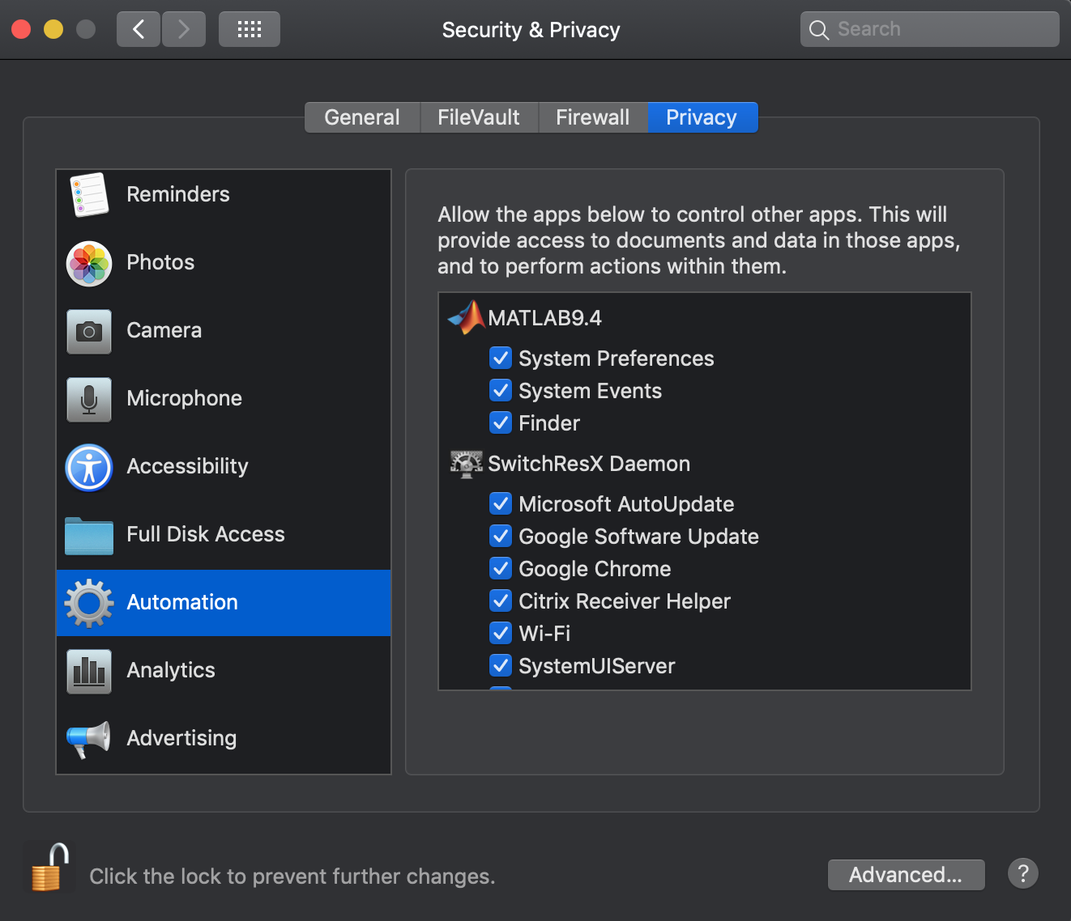

### B. Install Psychtoolbox (Already have it? Go to step 3.)

We use Psychtoolbox in our MATLAB programs to control the display. Follow this link to install Psychtoolbox:

<http://psychtoolbox.org/download/>

1. Carefully follow the instructions at the Psychtoolbox website. It is not entirely automatic. It needs your help to finish the installation. For example, you may need to install additional software such as svn and Gstreamer, depending on your Operating System. svn is included in Apple's free XCode developer software, so if you don’t have svn, when DownloadPsychtoolbox tries to use svn, you’ll get a dialog box from MacOS asking if you want to download XCode from the App Store, for free. Say “yes”. More likely you already have an obsolete version of svn, which will fail with a misleading error message. Again the solution is to install XCode (free) from the App Store. The documentation provides all the details. So just follow their instructions.
2. **macOS**: February 2018. DownloadPsychtoolbox or UpdatePsychtoolbox might fail because your obsolete svn is rejected by the Github server. Unfortunately the error message from Github is misleading, saying “option not available” rather than “your svn is obsolete: update it”. You can install the new svn by installing (free) XCode from the App Store. You might still have the problem of using an obsolete svn if you have an old version of svn lying around, e.g. at /opt/subversion/bin/svn. The Terminal command

which -a svn  
shows you all the versions of svn in your path. The Psychtoolbox function GetSubversionPath tells you which svn you’re using. You should delete all the obsolete ones, leaving just the current svn at /usr/bin/svn. (Thanks to Mario Kleiner and microfish@fishmonkey.com.au.)

1. If you already have Psychtoolbox, from some time ago, please update to the latest version by typing in the Command Window:  
   UpdatePsychtoolbox
2. Try running GratingDemo —just type it in MATLAB’s Command Window—to confirm that Psychtoolbox is installed and can control your display.
3. Run this to confirm that sound works:

Snd('Play',MakeBeep(256,1));

It should beep for one second. If you encounter problems, get advice by running:  
 help PsychPortAudio

1. Type Speak('hello') to confirm that speech synthesis works.
2. **macOS**: In order for Psychtoolbox to be able to load the current DrawText plugin you must install the X11 Quartz window package:   
   <https://support.apple.com/en-us/HT201341>  
   In case of trouble, type “help DrawTextPlugin” in the MATLAB Command Window.
3. **macOS**: *Delete obsolete version of libfreetype.6.dylib in MATLAB* (most versions up to and including 2018a). In order for Psychtoolbox to be able to load the current DrawText plugin from X11 Quartz, you must delete or rename this obsolete (version 18) library in MATLAB (most versions up to and including 2018a):   
   /Applications/MATLAB/bin/maci64/libfreetype.6.dylib  
   In case of trouble, see “help DrawTextPlugin” in the MATLAB Command Window. If you have trouble, Mario Kleiner suggests using the macOS Terminal app to find all instances of this file on your disk:

find / -name 'libfreetype.6.dylib'

(ignore the many “Permission denied” warnings), and then checking the version number of each one, e.g.

otool -L /opt/X11/lib/libfreetype.6.dylib

As of this writing (June 2018), you want compatibility with version 19. Having an extra obsolete library (e.g. compatibility version 18) can cause trouble, because it may be found and used in place of the current library. Remove or rename any obsolete copy. In my experience installing on dozens of Macs it was always enough to just delete the one inside MATLAB, as explained above.

1. **Microsoft Windows** with GNU/Octave: The Draw Text Plugin libraries are bundled with Octave. In case of trouble, see “help DrawTextPlugin” in the MATLAB Command Window.
2. **Microsoft Windows** with MATLAB: You will need to install the GStreamer multi-media framework - see "help GStreamer" for installation instructions. Otherwise Psychtoolbox will use the old lower quality GDI text renderer instead. In case of trouble, see “help DrawTextPlugin” in the MATLAB Command Window.
3. Run DrawSomeTextDemo to confirm that you’re getting high-quality styled text. **Note**: the first time you load the DrawText plugin there will be a one-minute delay as it converts your fonts to its format. Be patient. If you get a warning message saying that Psychtoolbox was unable to load the DrawText plugin, the message may give you a hint for what’s wrong and how to fix it.
4. **macOS:** *Use a computer account with admin privileges and allow MATLAB to control your computer.* This is required for several AppleScript routines that control the Brightness and Autobrightness settings in the System Preferences:Displays panel. The Applescripts work only if your account has “admin” privileges, and you have granted MATLAB permission to control your computer. Open the System Preferences: Security and Privacy: Privacy tab. Select Accessibility. Click to open the lock in lower left, providing your computer password. Click to select MATLAB, allowing it to control your computer. Click the lock to close it. You can confirm that it’s correctly enabled by typing AutoBrightness(0). If it has permission, it returns 0 or 1 (indicating autobrightness is off or on), but will return -99 if it lacks permission.
5. **macOS***: Install the Psychtoolbox kernel driver.* For this installation, I think you need to temporarily [disable the System Integrity Protection](https://www.macworld.co.uk/how-to/mac/how-turn-off-mac-os-x-system-integrity-protection-rootless-3638975/) (click the link). You should reenable it once you’re sure the kernel driver is installed. If there might be an old copy of the kernel driver, begin by running these two commands in Terminal:  
   sudo kextunload /System/Library/Extensions/PsychtoolboxKernelDriver.kext  
   sudo rm -R /System/Library/Extensions/PsychtoolboxKernelDriver.kext  
   Then install the kernel driver by running these two commands into Terminal:  
   cd /System/Library/Extensions/  
   sudo unzip /Applications/Psychtoolbox/PsychHardware/PsychtoolboxKernelDriver64Bit.kext.zip  
   (Adjust the address accordingly if your Psychtoolbox is not in the Applications folder.)   
   In my lab, we use this:  
   sudo kextunload /System/Library/Extensions/PsychtoolboxKernelDriver.kext  
   sudo rm -R /System/Library/Extensions/PsychtoolboxKernelDriver.kext  
   cd /System/Library/Extensions/  
   sudo unzip ~/Dropbox/PelliLabSoftware/Psychtoolbox/PsychHardware/PsychtoolboxKernelDriver64Bit.kext.zip  
   Several minutes after running those Terminal commands, the extension should load automatically. Sometimes the macOS seems to block the installation without giving you any notice. For some explanation, type into MATLAB:  
   help PsychtoolboxKernelDriverCurrently I believe the Psychtoolbox Kernel Driver helps only if your video driver is from AMD (aka Radeon). You can confirm that it’s loaded by typing this command into MATLAB:  
   psychtoolboxKernelDriverLoaded=~system('kextstat -l -k | grep PsychtoolboxKernelDriver > /dev/null')  
   It returns 1 if loaded and 0 otherwise.

### B. Install mQuestPlus (Already have it? Go to C.)

Some of our MATLAB scripts use the mQuestPlus toolbox to measure the psychometric function. Follow this link to get mQuestPlus:

<https://github.com/BrainardLab/mQUESTPlus>

Please put it in your Applications folder. Make sure the folder name is precisely "mQuestPlus". You might need to remove a trailing "-master".

### C. Install NoiseDiscrimination

1. Use GitHub to clone the NoiseDiscrimination software, making a local repository on your disk:   
   <https://github.com/denispelli/NoiseDiscrimination/>

My favorite GitHub client is Tower. It’s much more intuitive than the free clients that I tried. Using GitHub makes it easy to keep updating your copy from the master as new features are added and bugs are fixed.

1. *For long viewing distances: Allow remote typing.* A normally sighted observer must be many meters away from the screen, and thus will be unable to reach a laptop keyboard attached to the screen. The quickest way to overcome this is for the experimenter to type what the observer says. A more convenient solution is to get a wireless or long-cable keyboard.
2. *Install the Sloan font.* Just double-click the Sloan.otf file inside the NoiseDiscrimination folder. The Font Book app will ask if you want to install it. Say yes.
3. *Measure distance.* If the viewing distance is more that 2 meters you’ll need a tape measure, with centimeters, or a laser measure.
4. *Run a script.* To test an observer, double click runNoiseDiscrimination or your own modified script. They're easy to write. Say "Ok" if MATLAB offers to change the current folder. The program automatically saves your data to the NoiseDiscrimination/data/ folder. (If necessary, the folder will be created.) The test takes 10 min to test one observer (with 20 trials per threshold), measuring four thresholds. (You can increase o.trialsPerRun in your script from 20 to 40 or more for a more precise threshold estimate.)
5. *Type “help NoiseDiscrimination”* in the MATLAB Command Window for documentation on use of NoiseDiscrimination.

### D. Optional: Install camera support

If your software will want to use your laptop’s built-in camera to photograph the observer’s eyes (as a cheap rough way to check fixation), then you must install the free MATLAB package that provides USB web cam support. Note that, though free, Mathworks demands an account name and email. If you don’t have one, they show you how to get one free. <https://www.mathworks.com/help/supportpkg/usbwebcams/ug/snapshot.html>

### E. Buy tools

1. A *meter stick* for short viewing distance; *Tape or laser measure* for long viewing distance. If the viewing distance exceeds a meter, a meter stick won’t be enough. It's important that you set viewing distance accurately, within five percent. You can measure it with a $10 tape measure marked in centimeters. A fancy $40 alternative is a Bosch laser measure, which gives you the answer in two clicks. The laser will work even with a mirror.

<http://www.amazon.com/gp/product/B0016A2UHO>

<http://www.amazon.com/gp/product/B00LGANH8K>

<https://www.boschtools.com/us/en/boschtools-ocs/laser-measuring-glm-15-0601072810--120449-p/>

An *eye patch.* Each person should have his or her own eye patch, to avoid transmitting germs. They come in various sizes. Choose one that comfortably fits your face. I suggest putting a piece of tape with your name on it, so everyone knows it’s yours.

<https://www.amazon.com/Black-Elastic-Eye-Patch-Single/dp/B00BCNKU2C>

[https://www.amazon.com/Flents-Eye-Patch-3-Pack/dp/B001THK0BM/ref=pd_bxgy_121_2](https://www.amazon.com/Flents-Eye-Patch-3-Pack/dp/B001THK0BM/ref=pd_bxgy_121_2?_encoding=UTF8&pd_rd_i=B001THK0BM&pd_rd_r=K9066RQC73P48G69HM6W&pd_rd_w=tPNe8&pd_rd_wg=rU6FK&refRID=K9066RQC73P48G69HM6W&th=1)

<https://www.amazon.com/FCAROLYN-Pirate-Leakage-Smooth-Comfortable/dp/B01CWRSWBW/ref=pd_bxgy_121_3>

<https://www.amazon.com/Adult-Elastic-Patch-Black-Package/dp/B000B63RNA>

For long viewing distance: *A wireless or long-cable keyboard* is highly desirable because a normally sighted observer viewing foveally has excellent vision and must be many meters away from the screen, and thus will be unable to reach a built-in keyboard attached to the screen. If you must use the built-in keyboard, then have the experimenter type the observer's verbal answers. I like the Logitech K760 $86 solar-powered wireless keyboard, because its batteries never run out. It's no longer made, but still available on Amazon and eBay (below). To "pair" the Logitech keyboard with your computer's blue tooth, press the tiny button on the back of the keyboard.

Logitech Wireless Solar Keyboard K760 for Mac/iPad/iPhone

<http://www.amazon.com/gp/product/B007VL8Y2C>

1. For long viewing distance: *Mirror.* In a small room, you might need a mirror to achieve a long viewing distance. When NoiseDiscrimination asks you about viewing distance, you can indicate that you're using a mirror by entering the viewing distance as a negative number. It will flip the display to be seen in a mirror. (You can also request this, in advance, by setting o.flipScreenHorizontally=1; in your run script.) I bought two acrylic front surface mirrors for this. 12x24 inches, $46 each from Inventables. Front surface mirrors preserve image quality, and acrylic is hard to break, making it safer than glass. I'm not yet sure how big a mirror one needs to accommodate observers of various heights, so I listed several of Amazon's offerings, ranging up to 24" by 48". The five-pack is a good deal, five 12"x24" mirrors for $67.

<http://www.amazon.com/Acrylic-Wall-Mirror-Size-24/dp/B001CWAOJW/ref=sr_1_19>

<http://www.amazon.com/Childrens-Factory-Look-At-Mirror/dp/B003BL7TMC/ref=sr_1_14>

<https://www.inventables.com/technologies/first-surface-mirror-coated-acrylic>

<http://www.amazon.com/12-24-Mirror-Acrylic-Plexiglass/dp/B00IVWQPUI/ref=sr_1_39>

<http://www.amazon.com/12-Acrylic-Mirror-Sheet-Pack/dp/B00JPJK3T0/ref=sr_1_13>

<http://www.amazon.com/Double-Infant-Mirror-surface-Approved/dp/B0041TABOG/ref=pd_sim_sbs_468_9>

THANKS to Mario Kleiner, currently the main developer of Psychtoolbox, and Paul Fan, [paul.fan@nyu.edu](mailto:paul.fan@nyu.edu), who seems to always know how to get new software to work.